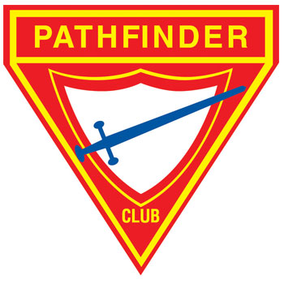
GREATER SYDNEY PATHFINDERS
200 CLUB MONTHLY REPORT FORM
Please complete and send the form before the 10th of the Month

CLUB ________________________________________________________ MONTH ________________________________

Monthly Pathfinder Activities: 1 Point for each done at least once
Date |  |  |  |  |  |  | Score
Description
Hall Meeting
Worship Time
Class Work
Craft or Honours
Drill or Marching
Games or Social
Community Service Activity
Uniform (Dress/Field) Worn
Management Meetings
Report sent by the 10th
Creative activity*

*Due to COVID and the fact that it makes the club a little more difficult to run, we have added an extra line for you to report on a Creative activity that you have done with your club that is not listed in the line items above. This extra activity will earn you 1 point. Please explain your Creative Activity here: _________________________________________________________________________________________ ___________________________________________________________________________________________________________________________________
Events (75% of Attendance) | Tick if done this month | Date | Percentage Attending | Score
Pathfinder Service Day
Map & Compass
Pathfinder Expedition
Fair or Camporee
Rally Day
Pathfinder Day
Pathfinder Open House
Club 2 night campout* (x3)
Community Service Activity (x2)
Pathfinder District Director Visit
Year Program to Pathfinder DD
Statistical Report to office by April
Investiture 80% Maximum of 30 points
Leadership Training or Trained # | MG / | PLA / | PSA /
Pathfinder e-Huddle
Pathfinder in-person huddle
Regional Tour Meeting

Annual Once Off Pathfinder Events: Worth 6 Points for each event
*Notification Form must be sent & approved by the office to gain points, include copy of your safety management plan for a bonus of 3 points. # Record those in training first and those who have completed second in each space eg. PLA 3/5

Director _________________________________ Signature ____________________________ Date ___________________
Please email report to Local District Director

